Example2:- Write app to get records from top to bottom , bottom to top, randomly and directly using PreparedStatement object.

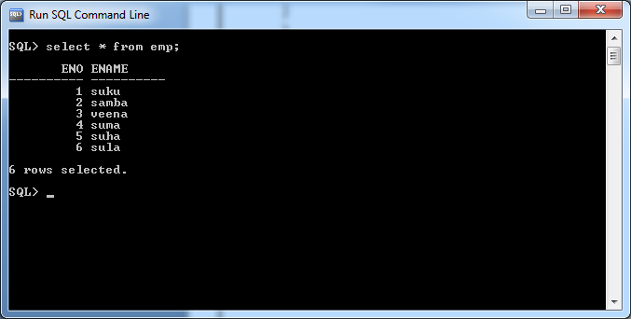

**package** com.raos.jdbc;

**import** java.sql.Connection;

**import** java.sql.DriverManager;

**import** java.sql.PreparedStatement;

**import** java.sql.ResultSet;

**import** java.sql.SQLException;

**public** **class** Sample {

**public** **static** String *qur*="select * from emp";

**public** **static** **void** main(String[] args) {

**try**(Connection con=DriverManager.*getConnection*("jdbc:oracle:thin:@localhost:1521:xe","sukumar","sukumar");

PreparedStatement s=con.prepareStatement(*qur*,ResultSet.***TYPE_SCROLL_SENSITIVE***,ResultSet.***CONCUR_READ_ONLY***);

){

**if**(s!=**null**) {

ResultSet r=s.executeQuery();

// Records From top to Bottom.

System.***out***.println("===========Top to Bottom==============");

**while**(r.next()) {

System.***out***.println(r.getRow()+"|"+r.getInt(1)+" "+r.getString(2));

}

System.***out***.println("===========Bottom to Top==============");

r.afterLast();

**while**(r.previous()) {

System.***out***.println(r.getRow()+"|"+r.getInt(1)+" "+r.getString(2));

}

System.***out***.println("=======Display Records Randomly and Directly==========");

r.last();

System.***out***.println(r.getRow()+"|"+r.getInt(1)+" "+r.getString(2));

r.first();

System.***out***.println(r.getRow()+"|"+r.getInt(1)+" "+r.getString(2));

r.absolute(2);

System.***out***.println(r.getRow()+"|"+r.getInt(1)+" "+r.getString(2));

r.relative(-1);

System.***out***.println(r.getRow()+"|"+r.getInt(1)+" "+r.getString(2));

r.relative(+2);

System.***out***.println(r.getRow()+"|"+r.getInt(1)+" "+r.getString(2));

r.absolute(-3);

System.***out***.println(r.getRow()+"|"+r.getInt(1)+" "+r.getString(2));

}

}

**catch**(SQLException e) {

}

}

}

